**Overview:**

The project’s goal is to provide an easy visualization of ecological traits, taxonomy, biogeographic regions, and current status of species. My main motivation for this project, besides liking reptiles, is to allow the reader to more intuitively explore possible relationships between traits in this dataset.

Related Work:

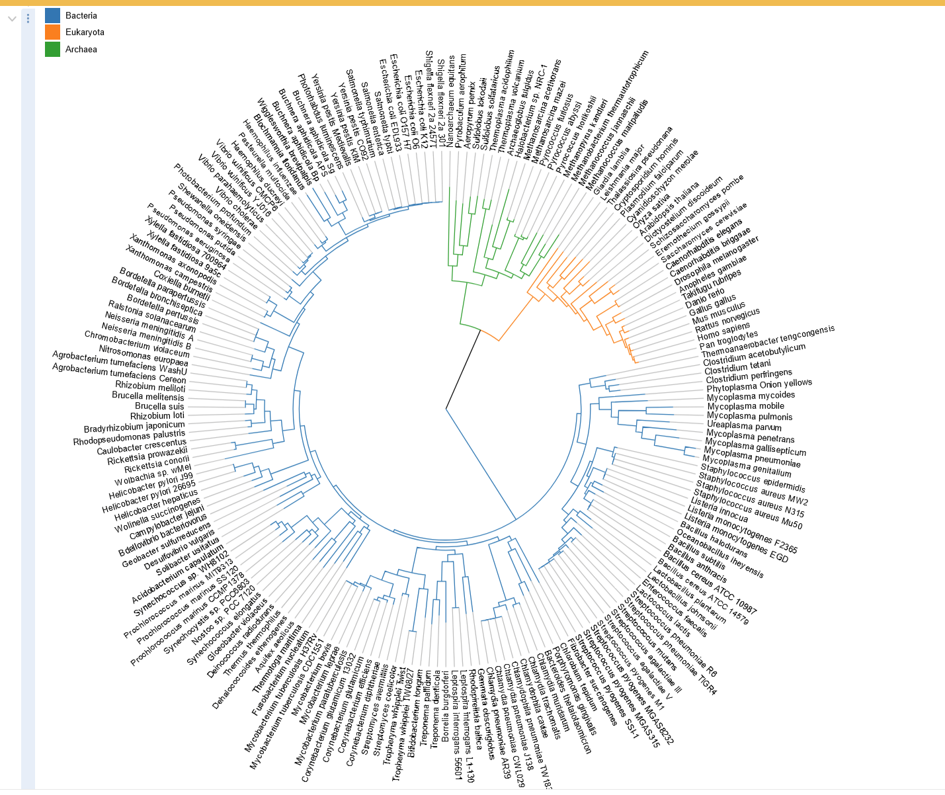

One of my main inspirations for the design of my visualization was this example in d3 that created radial graph of various types of bacteria.

<https://d3-graph-gallery.com/>

<https://observablehq.com/collection/@d3/gallery?page=2>

<http://tolweb.org/tree/>

This was another website that inspired me to create an interactive tree to visualize species.

**Questions:**  
How do certain traits affect a species conservation status?

How are different traits related across species?

What patterns could be seen when looking at the biogeographical regions, traits, and conservation?

It was not originally going to be focusing heavily on conservation status, but it is the most impactful correlation that could be found in these visualizations.

Some new questions that I found from going through the data were:

How does longevity and clutch sizes affect their conservation status?

**Data:**  
Source: <https://figshare.com/articles/dataset/ReptTraits_a_comprehensive_database_of_ecological_traits_in_reptiles/24572683>

**Exploratory Data Analysis”**  
 A pie chart to classify the Order each species was originally used to visualize the data. Doing this revealed to me the approximate distribution of the data, and they were mainly separated into four categories with one majority.

Plotting each point in a scatter plot revealed that a significant portion of the data was NA, or the dataset did not contain some information for a species. Additionally, the scatter plot revealed that the data often contained missing points for the species.

**Design Evolution:**  
 My original idea was to have a tree chart to visualize the division and splits in taxonomy, but it was more visually interesting to create one that was radial. My current issue with that for now is the lack of readability due to the number of points. There was originally an idea to visualize body size by representing it with linked nodes, but I decided that it may not be feasible with the amount of time and my current level of experience. Unfortunately, I am still somewhat undecided on my different visualizations. For now, the main visualization will be a radial design that is using hue and linked points for their marks and channels.

The node tree was too cumbersome for each species name and the dendrogram was trimmed to instead map until genus instead of each species as a node. Each node is displayed and colored by a legend with a tooltip displaying a name.

Ideally in the future, clicking on each node in the dendrogram would dynamically zoom in and create a smaller representation of that specific branch rather than the current mess.

A heatmap and a scatterplot were considered for a more interactive visualization

**Implementation:**  
 Currently lacking in two more visualizations and interactions. The future intent and functionality of the design is to use the other two visualizations to highlight and narrow down the list of species within the radial graph when selected. For example, I plan on having another visualization for the map showing the distributions of species in the eight main geographical areas. Another visualization that I am planning to create is another chart that shows the prominence of certain traits. Clicking on either one will add additional filters to the big dendrogram and zoom. Clicking on a node should create a small scrollable list that will display all info about that species

The actual implementation of the current design is a radial dendrogram with a zoom feature and text for each species order->suborder->family->genus. A tool tip can be displayed in each visualization showing their current taxonomic level and name. In the top right, the scatter plot shows the average longevity of each species and the average number of offspring they produce. A tooltip also shows the species name of the hovered over dot. The heatmap on the bottom right shows the conservation status to the taxonomic level. A checkbox exists to filter out the least concerned status, due to a majority of the species being in there.

**Challenges faced**: scaling and plotting data  
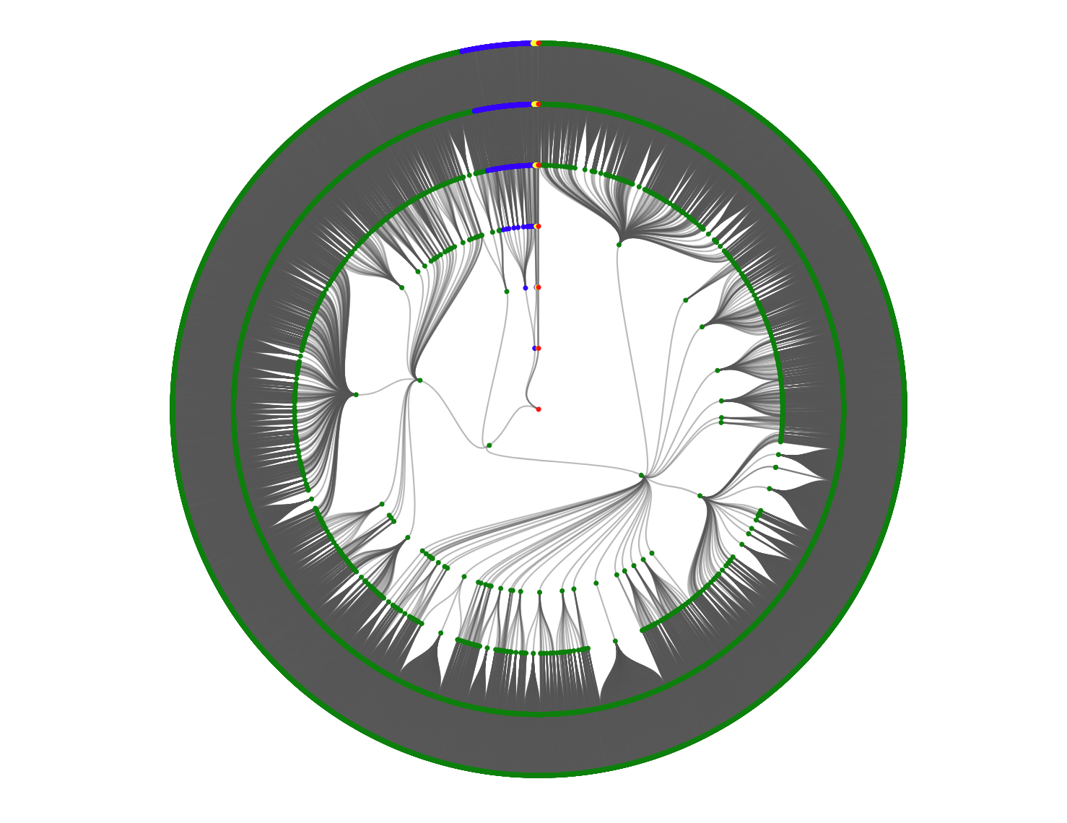  
A legend will be added and scaling will be fixed for this visualization

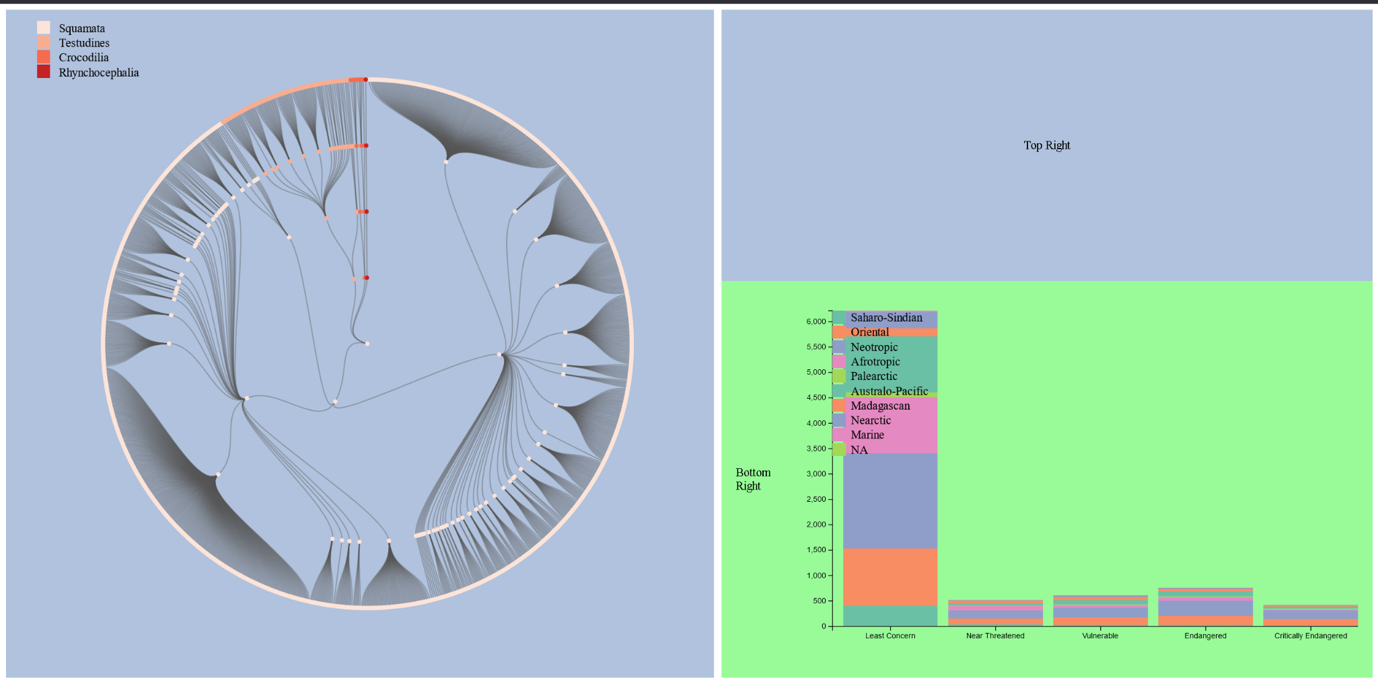

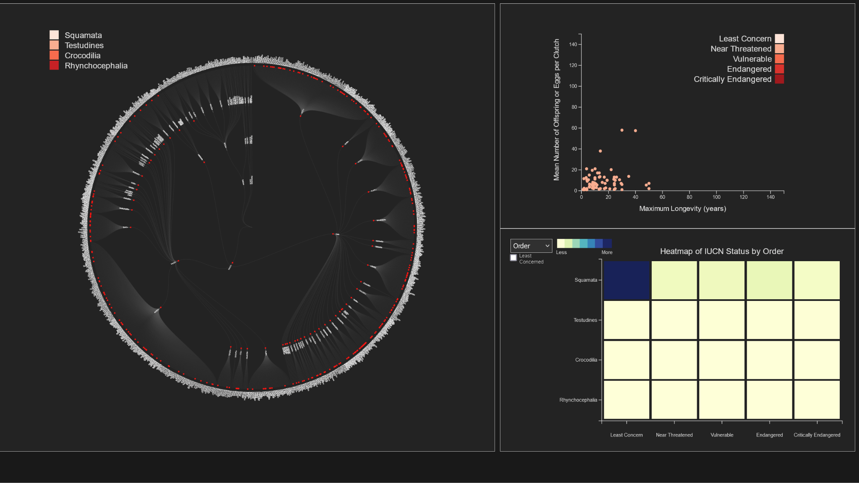

Evaluation:  
 The visualizations could be further improved with more optimization in terms of sorting data. If I had more time, the switch between taxonomic levels would create a more legible y-axis for the heatmap. As it is, the heatmap gets too dense when swapping to the less broad taxonomic levels. I learned that despite the small number of testudines(turtles) sampled in the data most of them were endangered or at risk. Each question was somewhat answered, although the relation between traits were less visible due to only having time to make a scatter plot for two traits. At this moment, I do not think the relationships between each visualization is as clear as I wanted them to be. Lastly, the connecting element between each visualization was weaker than I expected and using the biogeographic regions would have been more helpful to create connections between each visualization.